**Project Report**

On

**Online Food Delivery**

By

**Rahul Madansing Rathod**

Under the Guidance of

**Prof. Leena Deshmukh**

**Master of Computer Application**

**P.E. Society’s**

**Modern Institute of Business Studies, Nigdi,**

**Pune-44**

**Savitribai Phule Pune University**

**2021-2022**

ACKNOWLEDGEMENT

It is my proud privilege to express my profound gratitude to the entire management of Progressive Education Society’s Modern Institute of Business Studies and teachers of the institute for providing me with the opportunity to avail the excellent facilities and infrastructure of the institute. The knowledge and values inculcated have proved to be of immense help to my career.

I am grateful to **Prof. Dr. Maithili Arjunwadkar (Director, MIBS)** for their astute guidance, constant encouragement and sincere support for this project work.

I express my sincere gratitude to **Prof. Leena Deshmukh (Project Guide, MIBS)** for their inspiration, constructive suggestion, mastermind analysis and affectionate guidance in my work, without which this project work completion would have been impossible for me. Sincere thanks to all my seniors and colleagues at the company for their support and assistance throughout the project.

I would like to thank all the faculties for providing me with an opportunity to pursue my industrial training, as it is an important part of the MCA course.

I feel proud and privileged in expressing my deep sense of gratitude to all those who have helped me in presenting this assignment. I would be failing in my endeavour if I do not place my acknowledgement.

**1.INTRODUCTION**

**1.1 Introduction of project**

Online food delivery is to order the foods of different categories, view and add to cart food, order food . It manages all the information about Users, food categories, update food & its price, order food etc. The purpose of this project is to build an website to reduce the manual work for order the food with different categories etc.

• This website will help in accessing the information related to the food delivery to the particular destination with great ease. The users can track the information related to their food with great ease through this website. The food information with different categories can also be obtained through this website.

**1.2 Existing System -**

In the existing system, all the records are not kept perfectly because all the work is done manually, so keeping up to date details of the food with prices, timings of bookings, food availability for booking, hotels availability is not done. Amount of the overall ordered food are given  
Thus, the existing system is very time saving and being manual work sometimes lead to a great loss as well.

**Need for Systems**

* Using computerized system time, accuracy factor are considerably change.
* To reduce documentation of work.
* Due to the system searching modification make easy.
* Easy report generation.

**1.3 Scope of Work**

This website will help in accessing the information related to the food delivery of the particular categories with great ease. The users can track the information related to their food dellivery with great ease through this website. The food delivering agency information can also be obtained through this website.

* + - Using computerized system, time accuracy factor are easily change.
    - To make existing system user friendly.
    - Due to the system modifications make easy.
    - To prevent unauthorized access. It maintain all details of book detail, add to cart details, customer entry etc.

**1.4 Operating Environment - Hardware and Software**

**Hardware Requirement-**

**Processor:** Intel (i5) processor or above

**Monitor:** color Monitor

**Speed: (Intel)** 2.60 GHz

**RAM:** 512 MB or above

**Software Requirement-**

**Operating system:** window 7

**Language:** HTML, CSS

**Back end:** SQL

**Technology:** PHP

**1.5 Detail Description of Technology Used**

HTML5 and CSS3 are used to develop the front end of the website that provides various component classes like Label, Button, Text field, etc.,

On the other hand, backend part of the website is written entirely in PHP. XAMPP is used, XAMPP is an easy to install Apache distribution containing PHP admin, mysql and more features it is easy to use and free.

The **PHP Hypertext Pre-processor (PHP)** is a programming language that allows web developers to create dynamic content that interacts with databases. PHP is basically used for developing web-based software applications. This tutorial helps you to build your base with PHP.

**HTML5** is the latest and most enhanced version of HTML. Technically, HTML is not a programming language, but rather a markup language. In this tutorial, we will discuss the features of HTML5 and how to use it in practice.

**CSS** is used to control the style of a web document in a simple and easy way.**CSS** handles the look and feel part of a web page. Using CSS, you can control the colour of the text, the style of fonts, the spacing between paragraphs, how columns are sized and laid out, what background images or colours are used, layout designs, variations in display for different devices and screen sizes as well as a variety of other effects.

**2. PROPOSED SYSTEMS**

**2.1 Proposed System**

Through this system, the propose system is highly automated and makes the food deliver much easier and flexible. The user can get the very right information at the very right time. This system will include all the necessary fields which are required during online delivery time. This system will be easy to use and can be used by any person. The basic idea behind this project is to save data in a central database which can be accessed by any authorize person to get information and saves time and burden which are being faced by their customers.

**2.2 Objectives of System**

main objective of the Online food delivery system is to develop a system that automates the processes and activities of a food delivery and the purpose is to design a system using which one can perform all operations related to food delivery.The Objective of this project is to develop a system that automates the process and activities of a food delivery and customer details. The purpose is to design a system using which one can perform all operations related to Food delivery and sight- seeing.

**2.3 User Requirements**

**FACT FINDING TECHNIQUE**

**Primary investigation:-**

We decide the requirements of all system elements and then allocate some subset of these requirement to software.

1. **Requirement analysis:-**

To understand the nature of the programs to be built, we must understand the information domain for the software as well as the required function, performance and interfacing.

1. **System design:-**

It is actually multistep process which focuses on for distinct attributes of the program:

1. Data structures.
2. Software architecture.
3. Procedural detail.
4. Interface characterization.

The design process translates requirement into a representation of the software that can be assessed for quality before coding begins.

1. **System coding:-**

The design must be translated into a machine-readable form. The coding step performs this tasks.

1. **System testing:-**

This process focuses on the logical internals of the software and functional externals.

1. **System maintenance:-**

It reapplies each of the preceding if cycle step to an existing program rather than a new one. There are certain problems encountered while applying classic life cycle paradigm.

1. ‘iteration’ causes problem in the application.
2. It is difficult to state all requirements explicitly by the customer.
3. The customer must have patience.

**3. ANALYSIS AND DESIGN**

**3.1 Entity Relationship Diagram (ERD)**

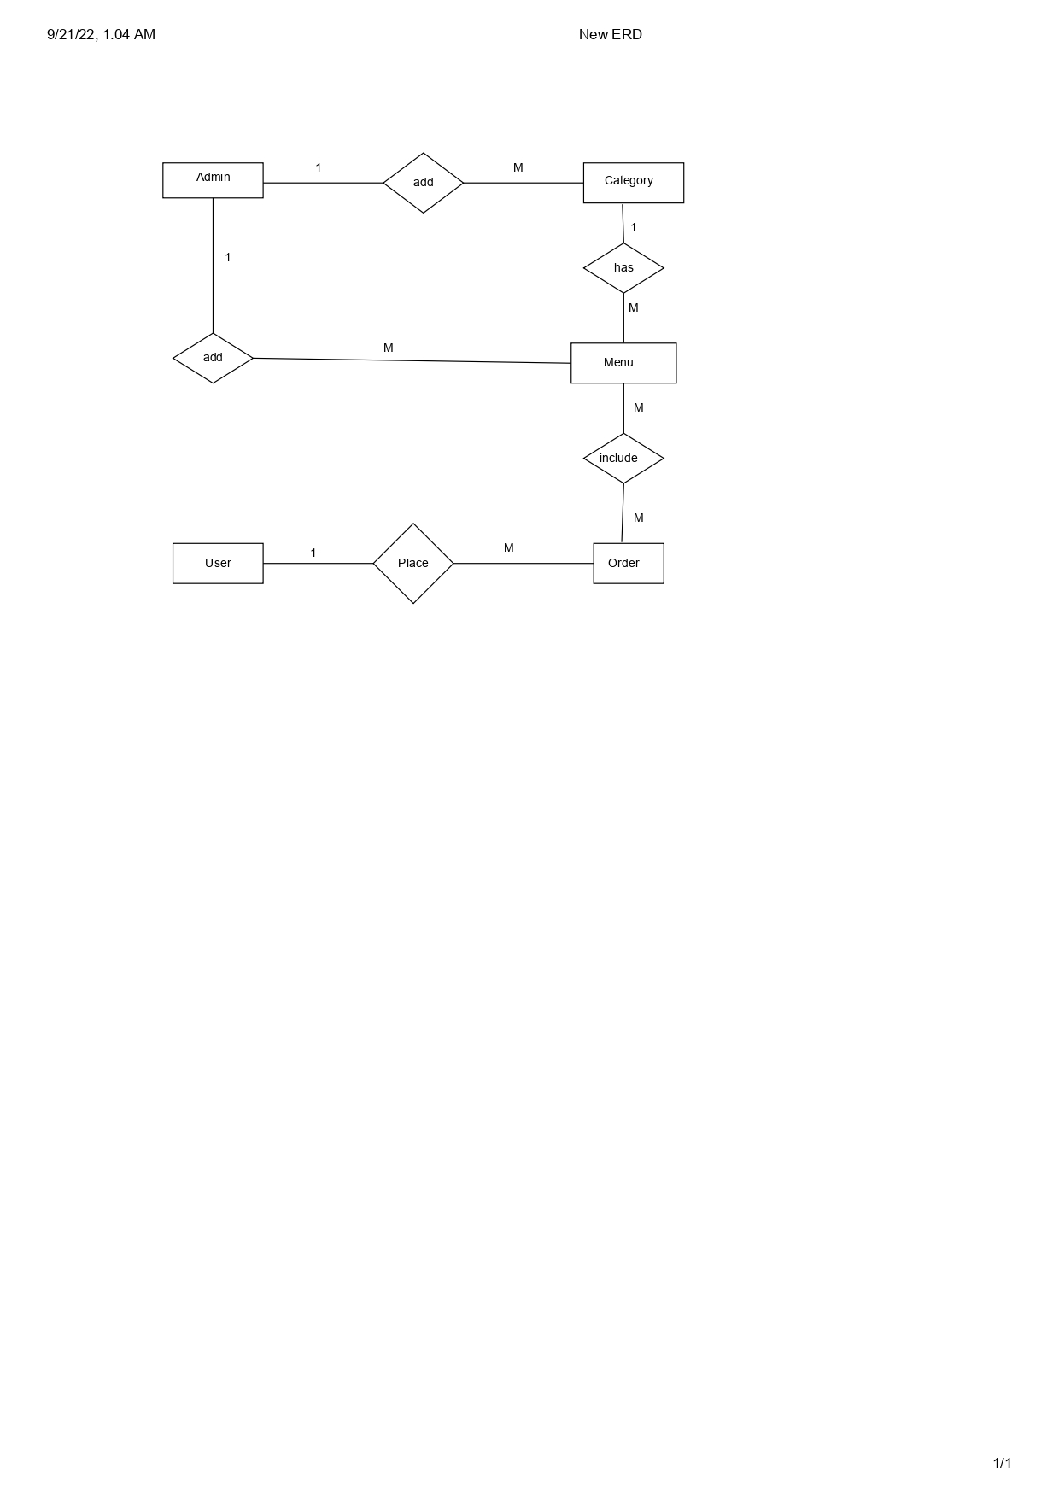

**3.2 Data Flow Diagram:-**

**0 – Level DFD-**

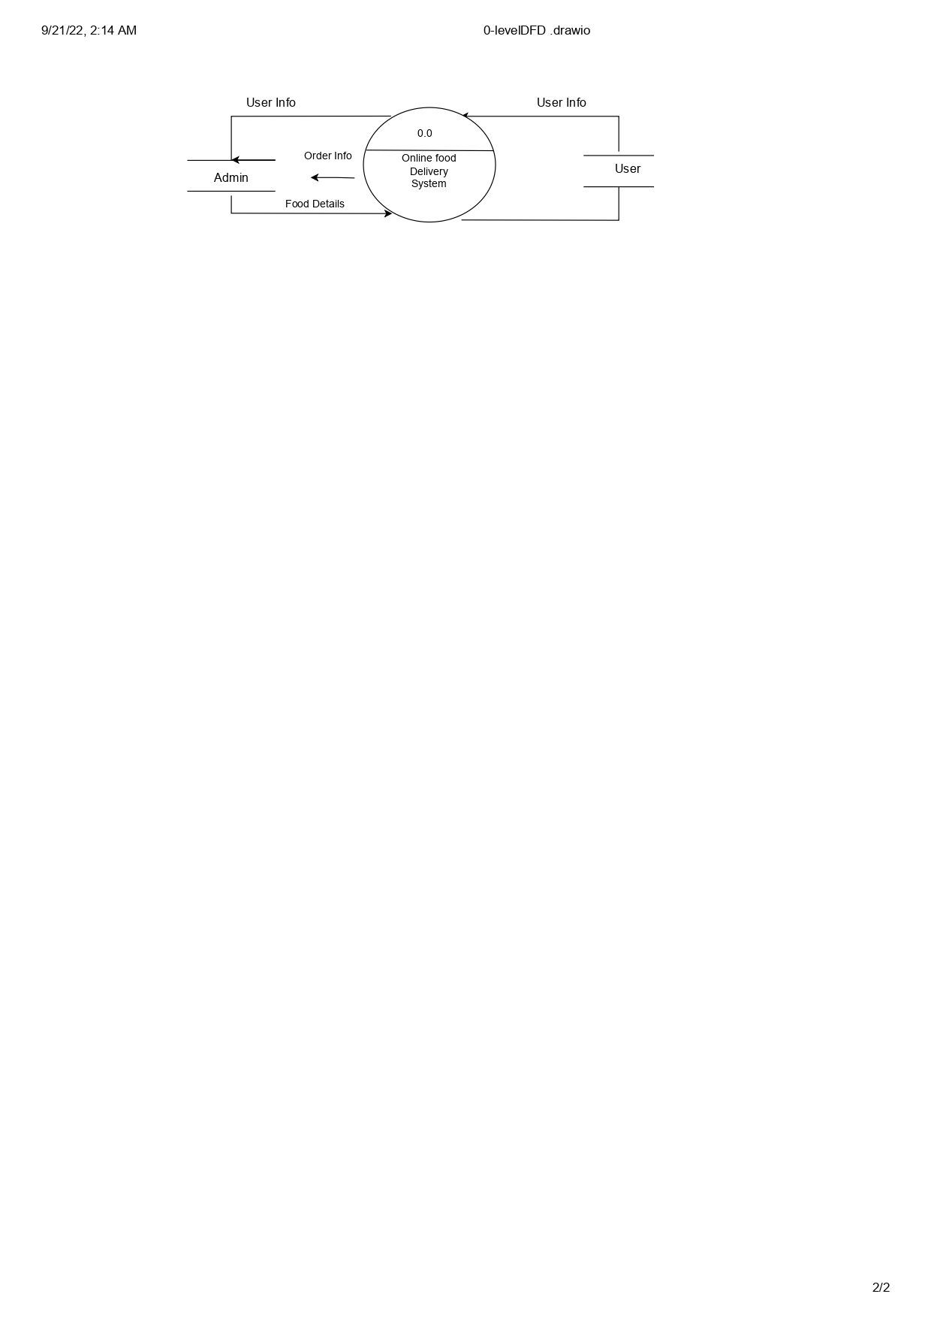

**1st Level DFD**

User Information User Information

Food Information Food Information

Food Category Food Category

User Admin

Ordered Food E-Waste

Order Records Transaction Records

**3.3 Object Diagram**

|  |
| --- |
| u:users |
| fname: Sagar  lname: Sharma  email: sagar@gmail.com  mobnum: 7894561230  addr: Nigdi  pass: 123 |
| signup ()  login ()  sub_req() |

|  |
| --- |
| Admin |
| user: text  pass: text |
| login ()  check_req()  assign_veh()  view_report() |

1...* Request 1

1

|  |
| --- |
| f: food |
| fid:2513  email: sagar@gmail.  food category: veg  food_name:Dal tadka  qyt: 1 |
| deliver food() |

|  |
| --- |
| foods |
| fo_name: Mobile  fid:2513  email: sagar@gmail.com |
| Order food() |

Select Get Notified Select

1…*

1…*

**3.4 Class Diagram :-**

|  |
| --- |
| Users |
| fname: varchar (15)  lname: varchar (15)  email: varchar (35)  mobnum: bigint (10)  addr: text  pass: varchar (15)  dt: datetime |
| signup ()  login ()  sub_req() |

|  |
| --- |
| a:admin |
| user: admin  pass: admin |
| login ()  check_req()  deliver food()  view_report() |

Request

1

Select Get Notified Select

|  |
| --- |
| food |
| f_name: text  bid: int (4)  email: varchar (35)  dt: datetime |
| order() |

1….*

|  |
| --- |
| food |
| bid: int(4)  email: varchar (35)  dt: datetime  qut of food: int(5)  veh_type: varchar(20)  vid: int(4) |
| Food ()  deliver() |

1…* 1…*

type

|  |
| --- |
| Veg- food |
| vid: int(4)  vname: text |
| Food description() |

|  |
| --- |
| Non- veg food |
| vid: int(4)  vname: text |
| Food description () |

**3.4 Use Case Diagram:-**

<<include>>

<<exclude>>

USER

<<include>>

<<exclude>>

ADMIN

**3.7 User Collaboration Diagram:-**

USER

OFDS

1. Acknowledgement
2. Acknowledgement
3. Confirm Window
4. Detail Receipt
5. Register
6. Login
7. Enter Food Order Details
8. Confirm order
9. Logout

**Admin Collaboration Diagram**

1. Acknowledgement
2. Users Food Requests
3. Gets Details of Assignment
4. Submits the Request
5. Login
6. Check Request
7. Assign Food Accordingly
8. Confirmation Window
9. Logout

ADMIN

OFDS

**3.8 Deployment Diagram**

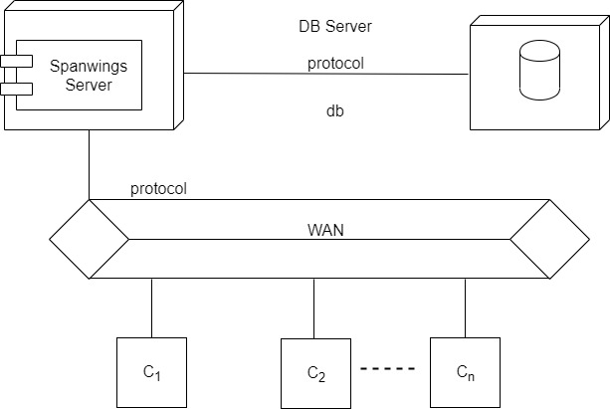

OFDS

SERVER

**3.9 Component Diagram**

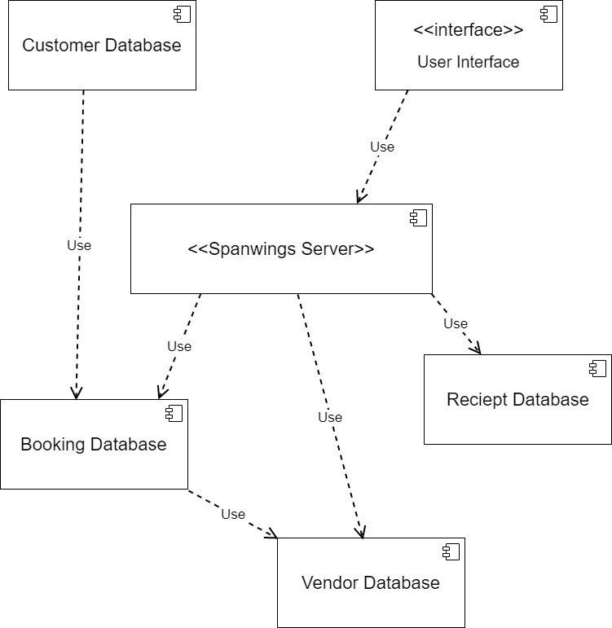

Admin

User

OFD

FOOD

OFDS

**3.10 Table Design**

**Users table:-**

|  |  |
| --- | --- |
| **Table Name** | Users |
| **Description** | This table provides information about all the Users that register into the system. |
| **Primary Key** | id |
| **Foreign Key** | - |

|  |  |  |  |
| --- | --- | --- | --- |
| **Sr** | **Field name** | **Type** | **Default** |
| 1 | id | int(11) | Not Null |
| 2 | name | varchar(20) | Null |
| 3 | mobile | varchar(10) | Null |
| 4 | address | varchar(50) | Null |
| 5 | email | varchar(30) | Null |
| 6 | password | varchar(30) | Null |

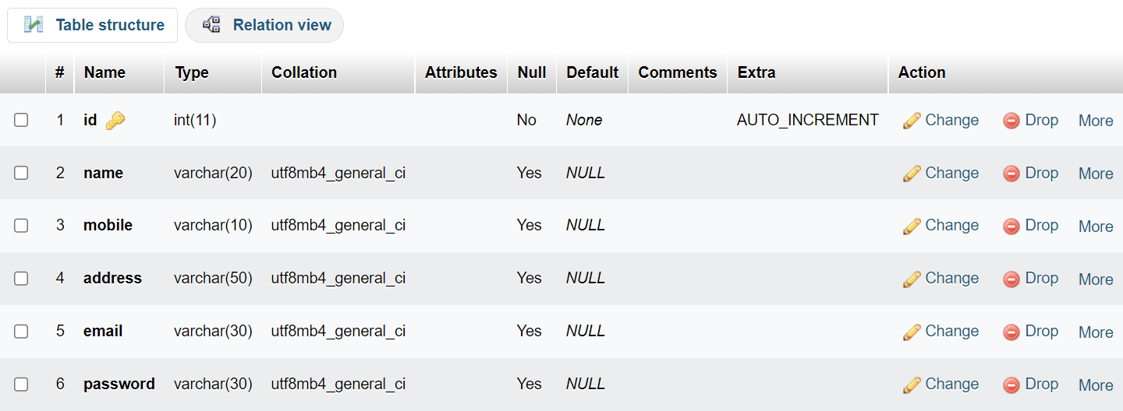

**Admin Table:-**

|  |  |
| --- | --- |
| **Table Name** | Admin |
| **Description** | This table provides information about the Admin that register into the system. |
| **Primary Key** | id |
| **Foreign Key** | - |

|  |  |  |  |
| --- | --- | --- | --- |
| **Sr** | **Field name** | **Type** | **Default** |
| 1 | id | int(11) | None |
| 2 | username | varchar(20) | Null |
| 3 | password | varchar(20) | Null |

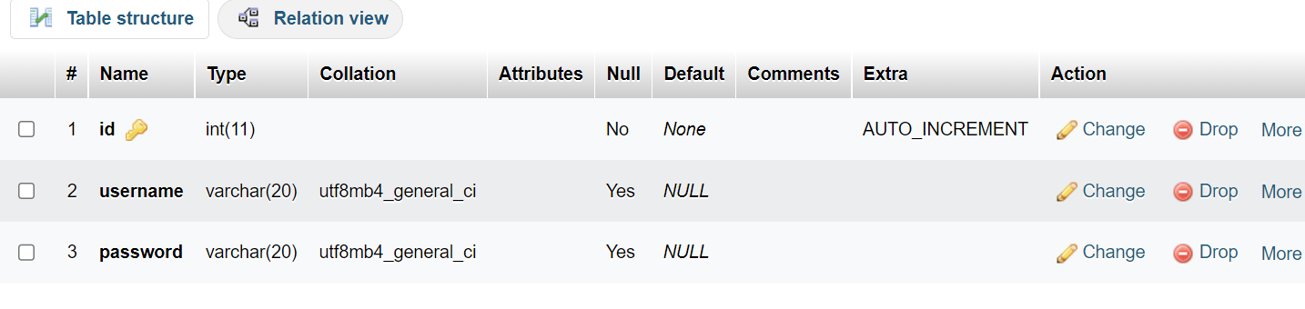

**Category Table:-**

|  |  |
| --- | --- |
| **Table Name** | Category |
| **Description** | This table provides information about the Food Category that register into the system. |
| **Primary Key** | id |
| **Foreign Key** | - |

|  |  |  |  |
| --- | --- | --- | --- |
| **Sr** | **Field Name** | **Type** | **Default** |
| 1 | id | int(11) | None |
| 2 | title | varchar(20) | None |
| 3 | image_name | text | None |
| 4 | featured | varchar(20) | None |
| 5 | active | varchar(20) | None |

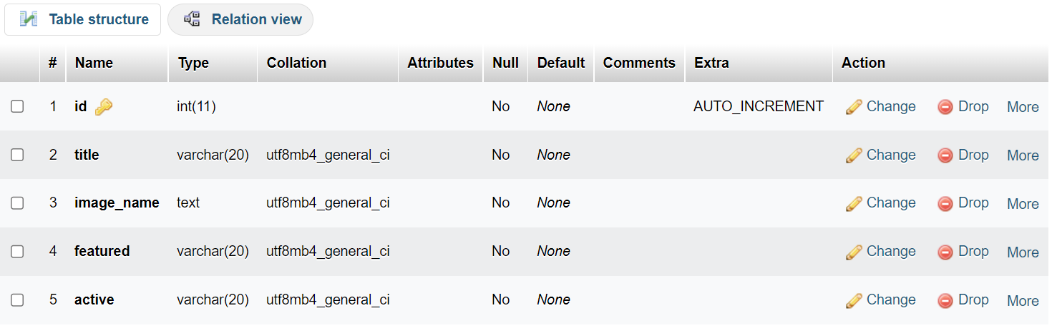

**Table Contact:-**

|  |  |
| --- | --- |
| **Table Name** | Contact |
| **Description** | This table provides information about the Contact that register into the system. |
| **Primary Key** | id |
| **Foreign Key** | - |

|  |  |  |  |
| --- | --- | --- | --- |
| **Sr** | **Feild Name** | **Type** | **Default** |
| 1 | id | int(11) | None |
| 2 | name | varchar(20) | Null |
| 3 | email | varchar(30) | Null |
| 4 | mobile | int(10) | Null |
| 5 | message | text | Null |
| 6 | create_date | date | None |

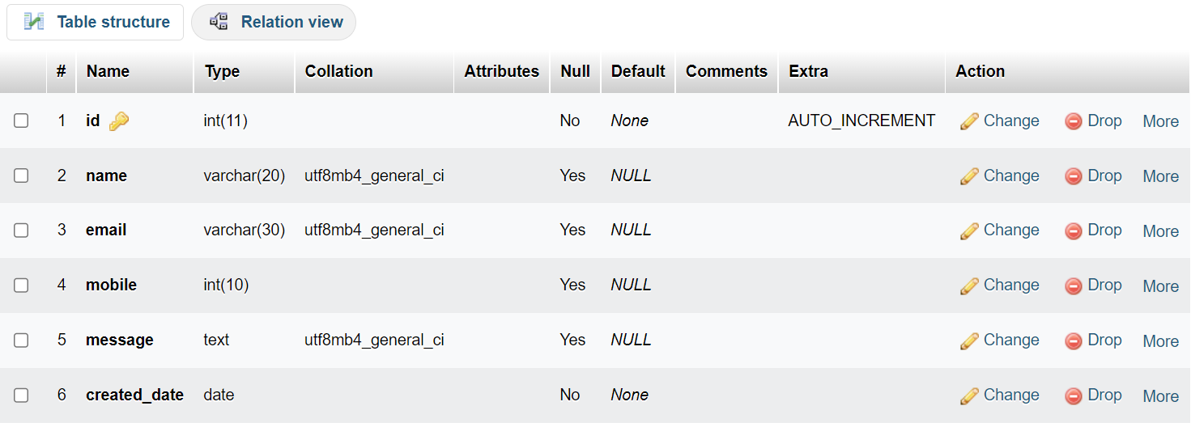

**Table Food:-**

|  |  |
| --- | --- |
| **Table Name** | Contact |
| **Description** | This table provides information about the Food that register into the system. |
| **Primary Key** | fid |
| **Foreign Key** | - |

|  |  |  |  |
| --- | --- | --- | --- |
| **Sr** | **Field Name** | **Type** | **Default** |
| 1 | fid | int(11) | None |
| 2 | title | varchar(20) | None |
| 3 | description | varachar(20) | None |
| 4 | price | floate | None |
| 5 | image_name | text | None |
| 6 | category_id | varchar(20) | None |
| 7 | featured | varchar(10) | None |
| 8 | active | varchar(10) | None |

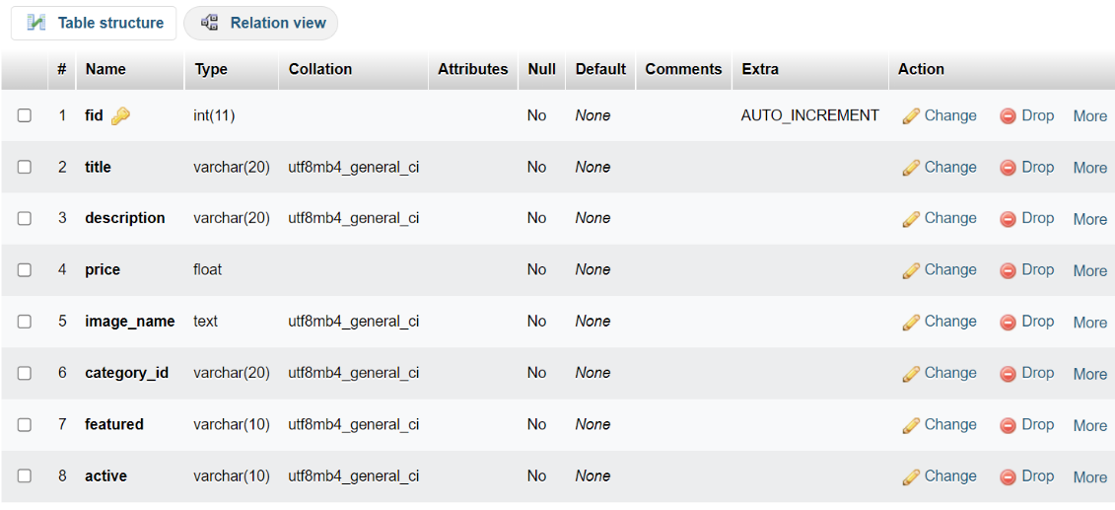

**Table Order:-**

|  |  |
| --- | --- |
| **Table Name** | Order |
| **Description** | This table provides information about the Food Order that register into the system. |
| **Primary Key** | oid |
| **Foreign Key** | - |

|  |  |  |  |
| --- | --- | --- | --- |
| **Sr** | **Field Name** | **Type** | **Default** |
| 1 | oid | int(11) | None |
| 2 | food | varchar(20) | None |
| 3 | price | float | None |
| 4 | qty | int(10) | None |
| 5 | total | float | None |
| 6 | order_date | date | None |
| 7 | status | varchar(20) | None |
| 8 | customer_name | varchar(20) | None |
| 9 | customer_contact | int(10) | None |
| 10 | customer_email | varchar(20) | None |
| 11 | customer_address | varchar(30) | None |

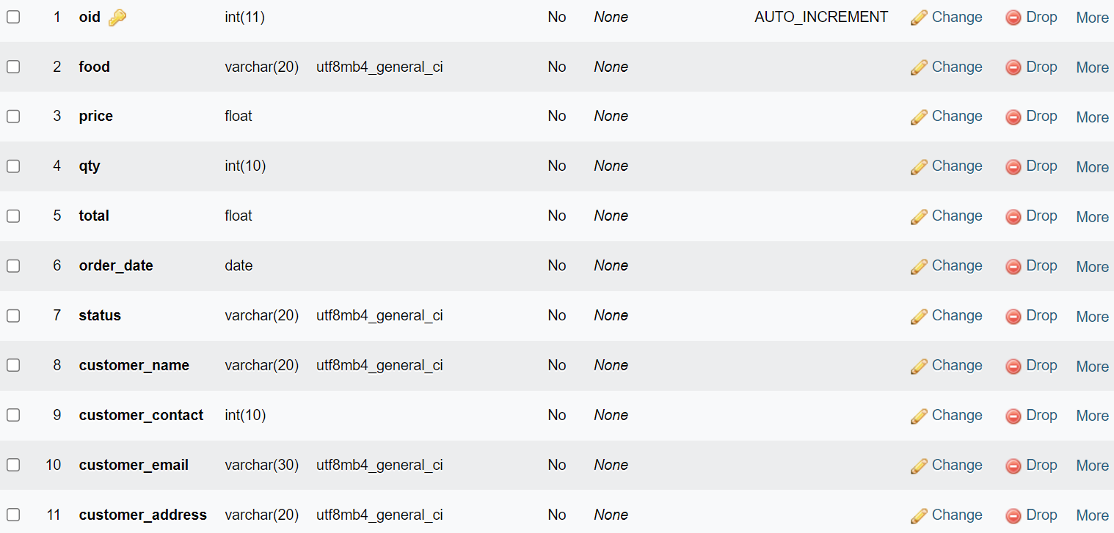

**4. Drawbacks and Limitations**

#### You might face technical issues

#### No backup

Possibility of errors occurs during runtime is more.

Risk of computer virus.

Systems store data on computer hard drive. This increases the risk of data loss

**5. Proposed Enhancements**

Easy order including self booking for user.

User and food order data System backup.

Cloud data management.

Printing users reports.

**6. Conclusion**

The process of the system we can consider here, can maintain the databases of the system. We can insert to the databases and retrieve all the information.

The main aim of this project is to help the user to order food easily. It makes all operation of the order easy and accurate. The standalone platform makes order management easy by handling requests and providing servers for the customers located at different parts of the various

cities. Different modules have been incorporated in this project to handle different parts and sector of the food delivery.

**7. Bibliography**

We have taken references from many resources like YouTube and many websites.

Websites:

<https://www.w3schools.com>

<https://www.javatpoint.com>

<https://www.stackoverflow.com>

**8. ANNEXURES**

**8.1 ANNEXURE 1 : USER INTERFACE SCREENS**

**User Sign up:**

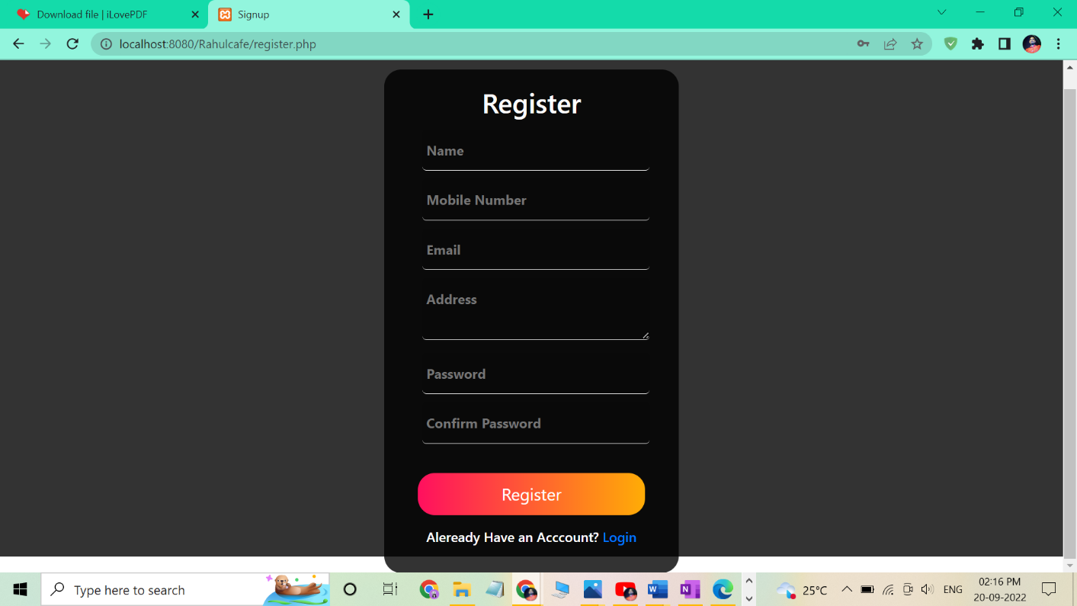

**User login:**

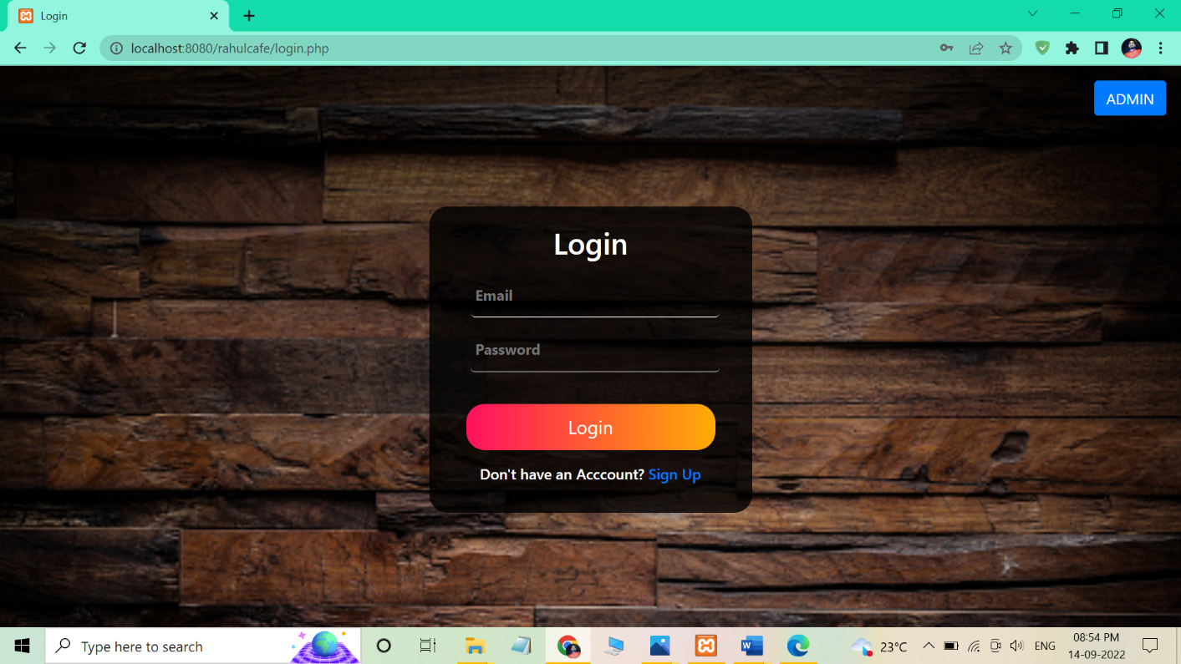

**User profile**

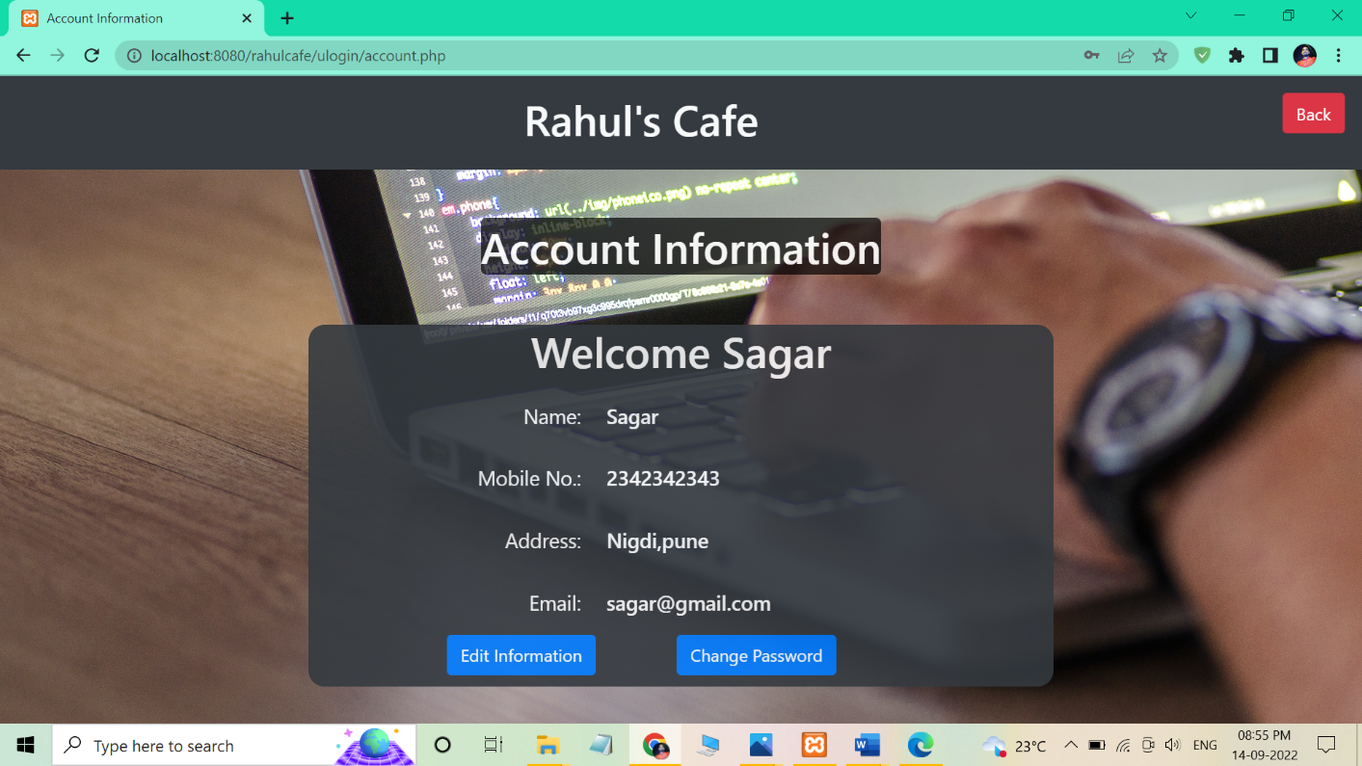

**User Entry for order food**

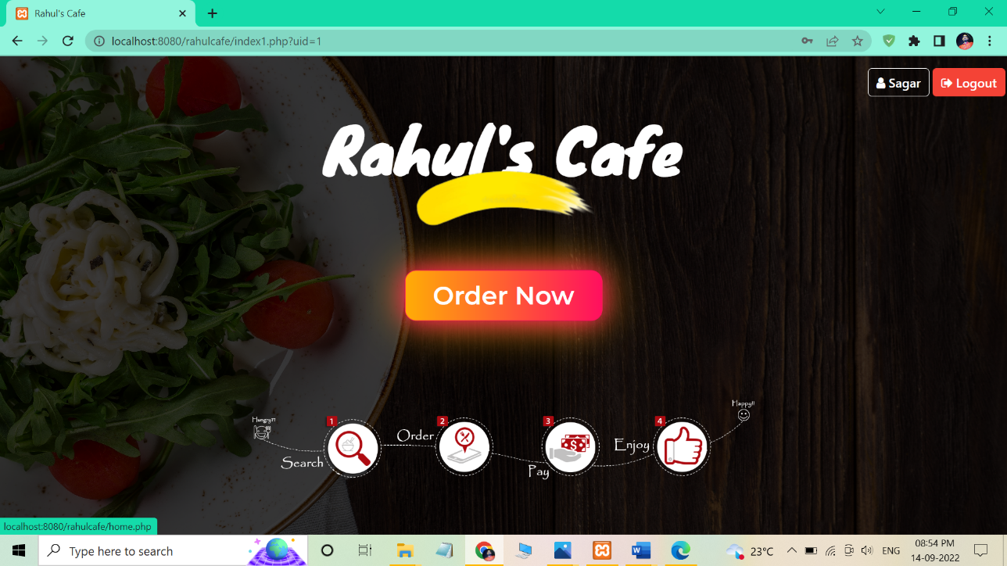

**Home Page**

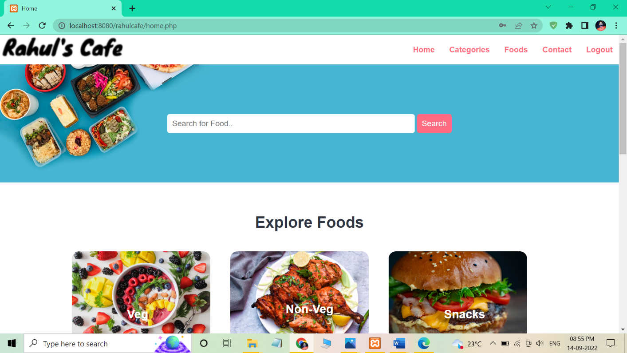

**View Category**

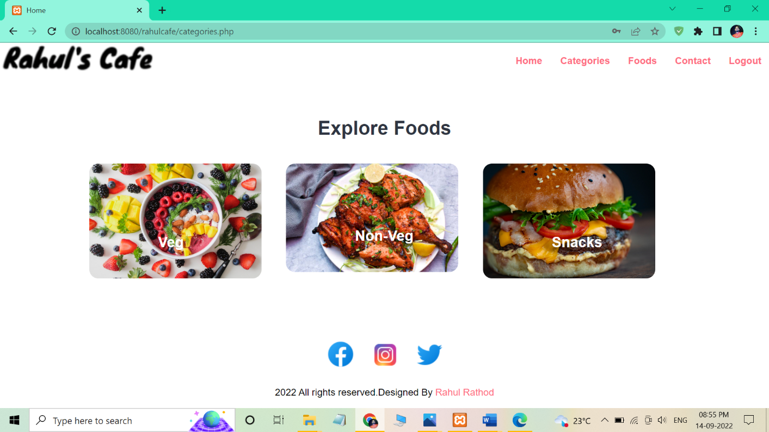

**View Food:**

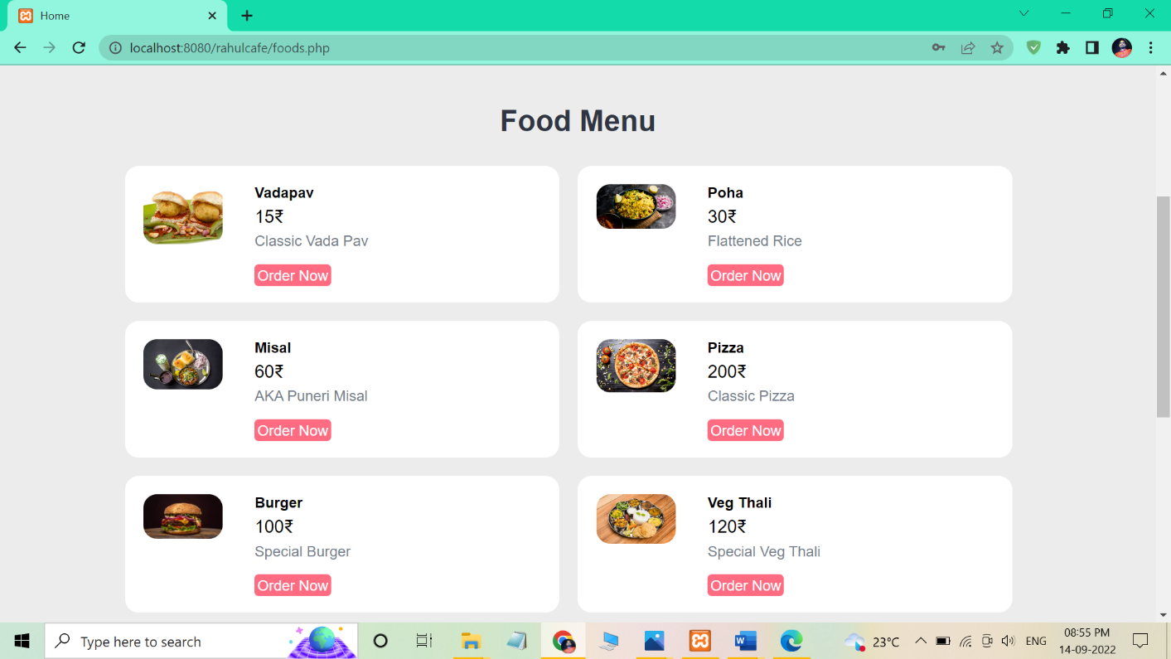

**Order Food**

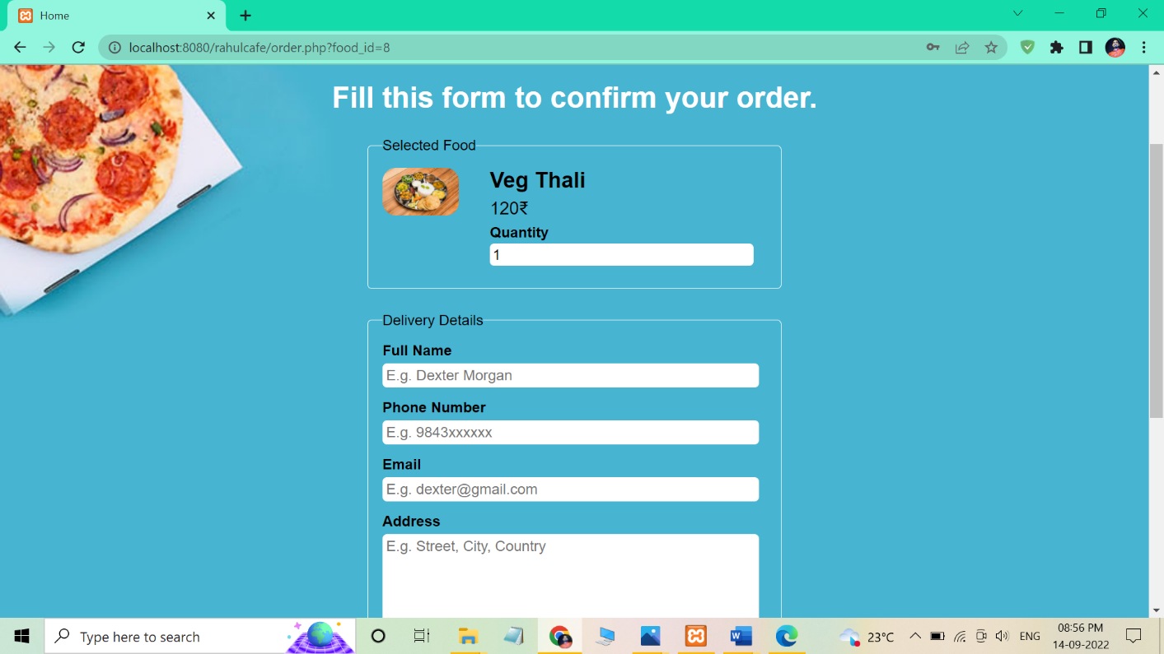

**Admin Login**

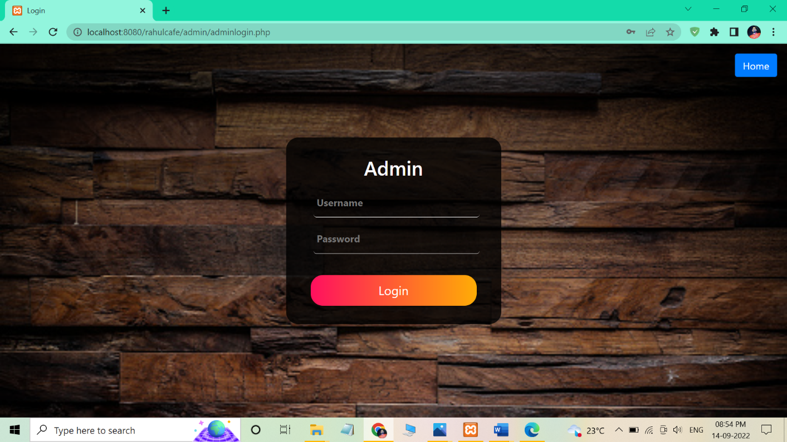

**Update Order status**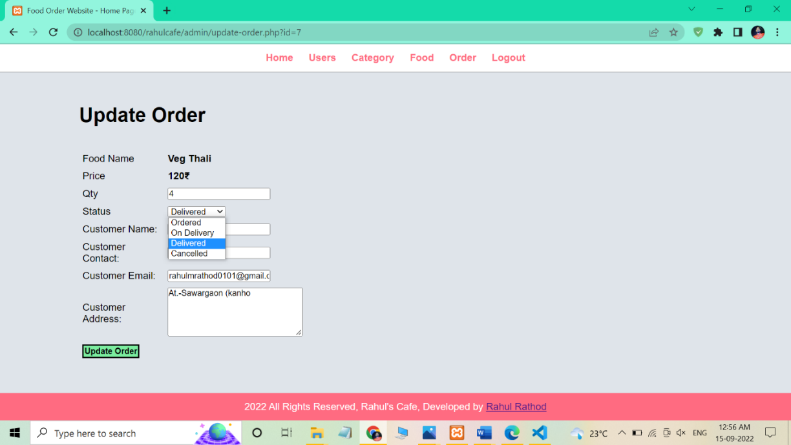

**8.2 ANNEXURE 2 : OUTPUT REPORTS WITH DATA ( if any)**

**View Dashboard**

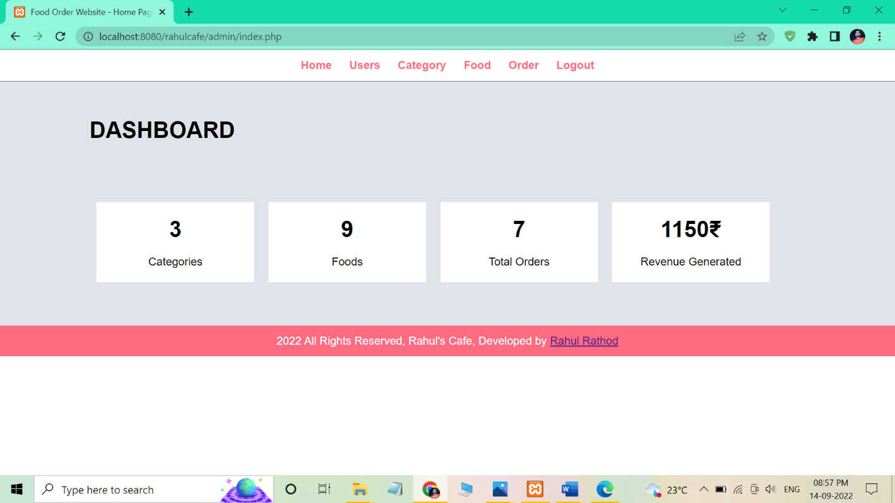

**View Foods**

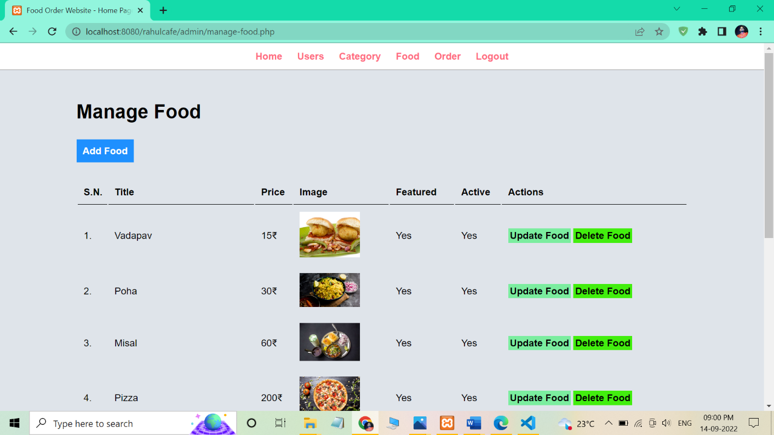

**View Users**

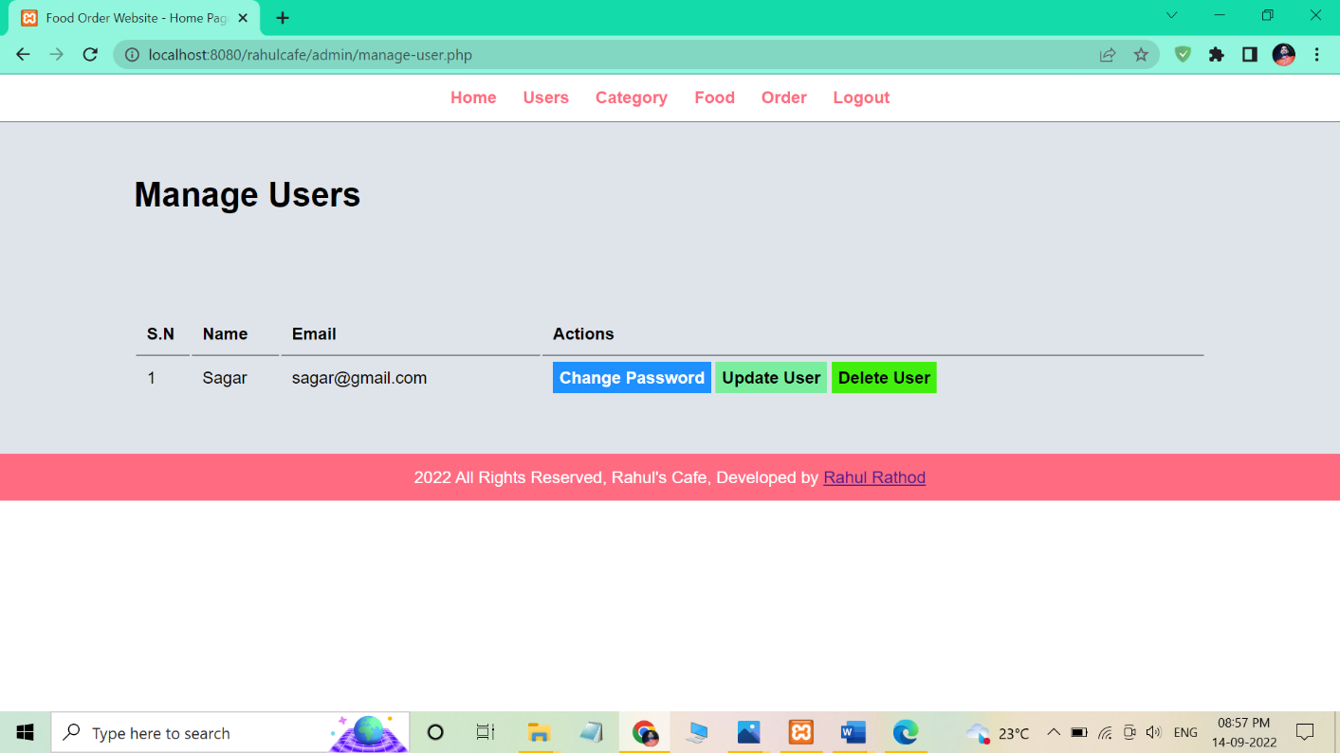

**View Category**

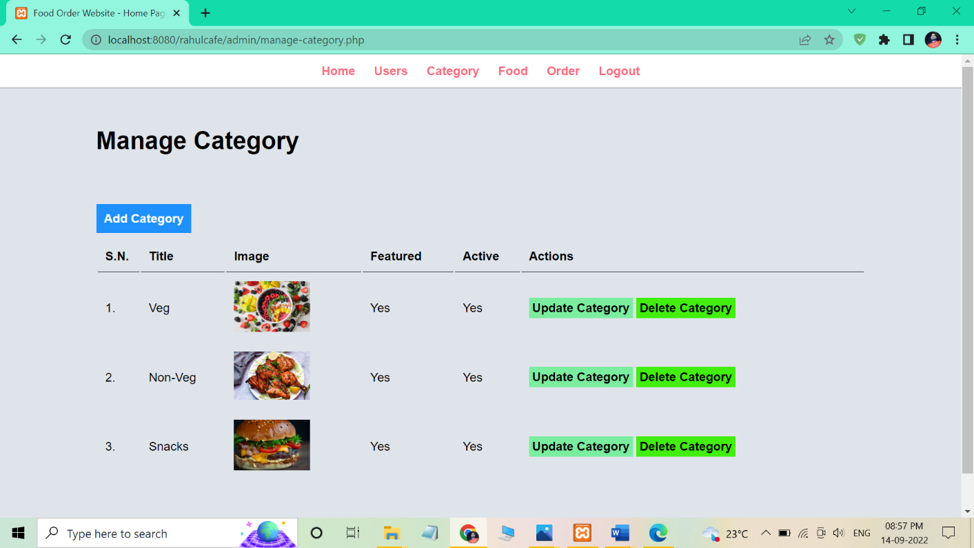

**View Order**

